Implement program to apply moving average smoothing for data preparation and time series forecasting
EX:No.6
DATE:

AIM:
Write a program to Implement program to apply moving average smoothing for data preparation and time series forecasting

ALGORITHM:
Step 1: Install required libraries (if not already installed).
Step 2: Import necessary libraries (pandas, numpy, matplotlib).
Step 3: Load air pollution data, parse dates, and set 'date' as the index.
Step 4: Remove duplicate timestamps and fill missing values.
Step 5: Select the 'pollution_today' column.
Step 6: Remove outliers using the IQR method.
Step 7: Ensure daily data frequency.
Step 8: Resample to weekly average (optional, not used in the plot).
Step 9: Create a figure and plot daily pollution levels as a line graph.
Step 10: Set labels, title, and legend for the plot.
Step 11: Show the plot.

CODE:
import pandas as pd
import matplotlib.pyplot as plt
file_path = "/mnt/data/Super_Store_data.csv"
df = pd.read_csv(file_path, encoding="latin1")
df.columns = df.columns.str.strip()
df['Order Date'] = pd.to_datetime(df['Order Date'], errors='coerce')
df.set_index('Order Date', inplace=True)
if "Sales" not in df.columns:
raise ValueError("Column 'Sales' not found in dataset.")
df['Sales'] = pd.to_numeric(df['Sales'], errors='coerce')
ts = df['Sales'].resample('M').sum().dropna()

window_size = 12 # 12-month moving average
moving_avg = ts.rolling(window=window_size).mean()
future_steps = 12 # Forecast for next 12 months
forecast_values = moving_avg.iloc[-1] # Last smoothed value as a baseline forecast
future_dates = pd.date_range(start=ts.index[-1], periods=future_steps + 1, freq="M")[1:]
forecast_series = pd.Series([forecast_values] * future_steps, index=future_dates)
plt.figure(figsize=(12, 6))
plt.plot(ts, label="Original Sales Data", alpha=0.5, color='blue')
plt.plot(moving_avg, label=f"{window_size}-month Moving Average", color="red", linestyle="dashed")
plt.plot(forecast_series, label="Forecast (Moving Avg)", color="green", linestyle="dotted")
plt.xlabel("Date", fontsize=12)
plt.ylabel("Total Sales", fontsize=12)
plt.title("Sales Trend - Moving Average Smoothing & Forecasting", fontsize=14)
plt.legend()
plt.grid(True, linestyle="--", alpha=0.6)
plt.show()

OUTPUT:

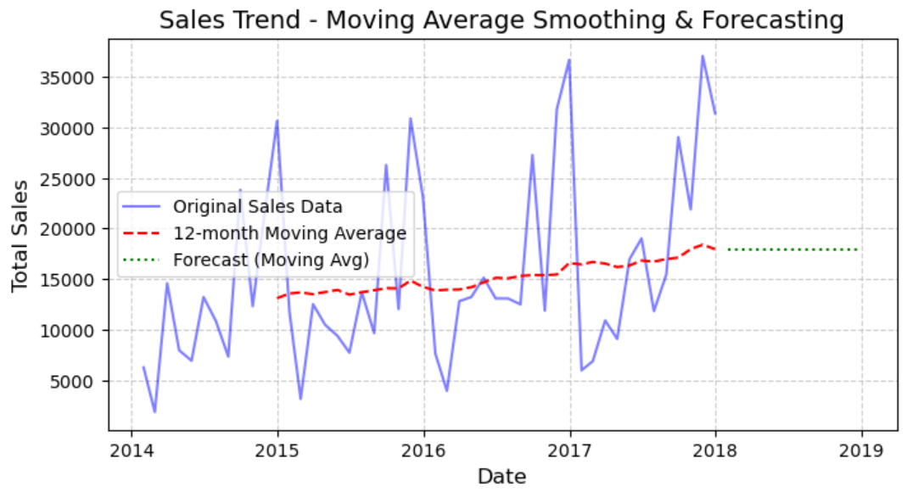

RESULT:
Thus, the program using the time series data implementation has been done successfully.

